In our first post-COVID offseason, the transfer market has already proven to be active…for some teams. There have been many notable departures in the CAA already: Tyson Walker leaving Northeastern for Michigan State, Zep Jasper moving from Charleston to Auburn, and, of course, Luke Loewe moving back to the Midwest to play for the Minnesota Golden Gophers. The CAA teams that have successfully recruited a transfer are Northeastern, Charleston, Delaware, Drexel, Elon, JMU, Towson, Hofstra, and UNC Wilmington. Obviously absent from this list of transfer participants is William & Mary, literally the only team in the conference without a transfer.

At the beginning of the offseason, us at No Bid Nation thought we would be an active buyer in the transfer market; we had obvious problems with three-point shooting, our best defensive player is leaving, and we had multiple scholarship players playing minimal minutes. The writing really seemed to be on the wall to pick up a player or two. And we still can! The coaches might just need some help identifying some realistic targets, and I will gladly offer my two cents.

Using a type of analysis called k-means clustering, I can match players of similar skill sets without ever having to open their ESPN page or watch film. (For those interested, the process groups players into *k* groups whose average values across a series of statistics minimize classifications of unlike players.)

While it will not perfectly classify players into specific groups (it won’t put *all* centers with other centers, for example), it is a good approximation that can crunch a lot of data on random basketball players! Before we begin, I have to give a shoutout to Bart Torvik and 247Sports, from which I pulled statistics for all players who played in the last two seasons of NCAA DI basketball.

**Let’s group these guys**

Before we get to the cool stuff, I will briefly go over the overview of the model. I have chosen only a subset of popular statistics to compare the players to limit the complexity of the model: two-point shooting, offensive rebounding, defensive rebounding, assists, turnovers, free-throw shooting, three-point shooting, blocks, steals, foul shot-field goal attempt ratio, rim shot percentage (of total shots), mid-range shot percentage, and dunk percentage. All variables are per 100 possessions in order to compare starters with substitutes, and are averaged across the two seasons for each player.

One boring question I have to deal with is the optimal number of groups to sort players into. A more concrete way to examine this is to pick the number of groups that minimizes the variation within each group (we do not want groups with unrepresentative averages). The chart below shows the total variation in the model on the y-axis for the number of clusters enumerated on the x-axis. It appears that at 7 groups, the model stops significantly improving. And since less complexity is better than more, we will roll with 7 as our magic number!

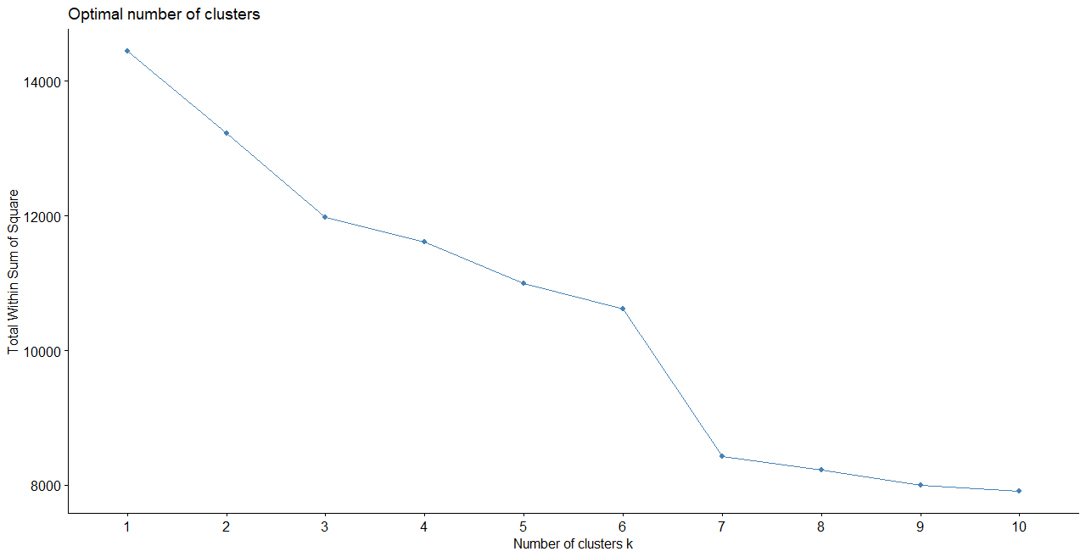

Running the algorithm now gives us seven groups of similar players. Let’s see if these groups make sense for the William & Mary roster:

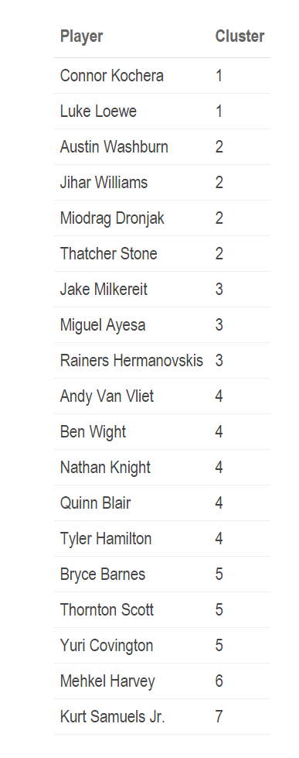

Cluster 1 puts Luke Loewe and Connor Kochera together; this checks out. I have often even commented that Kochera is a miniature version of Loewe: can drive to the hoop and shoot the three-ball, loves taking charges, and has a calm demeanor. Funny how the model got that last part spot on.

Cluster 2 also groups most of the players who got almost zero playing time over the last two years, that checks out. Jake Milkereit, Miguel Ayesa, and Rainers Hermanovskis comprise cluster 3, which seems to be grouping players who are good enough to play but did not put together good shooting performances thus far.

Cluster 4 may be the most controversial by placing our two most dominant players of the last two years (Knight and Van Vliet), two players who have a somewhat similar playstyle (Blair and Wight) with Tyler Hamilton, who was never considered dominant. Perhaps the model sees his high percentage of shots around the rim?

Cluster 5 identified all of our point guards, great! Cluster 6, as you will see later, identifies traditional centers (sorry Ben), and cluster 7 is made especially for Kurt Samuels (and other benchwarmers).

In general, the clusters can be thought of as these archetypes: playmaking mid-range shooters (Cluster 1); turnover-prone benchwarmers (Cluster 2); three-point specialists and friends (Cluster 3); shooting big guys (Cluster 4); traditional point guards (Cluster 5); traditional centers (Cluster 6); non-turnover-prone benchwarmers (Cluster 7). Excellent, so now this model can separate the wheat from the chaff. Let’s see who William & Mary can (realistically) get to join us in Williamsburg.

**Who are these guys anyways?**

Our biggest offensive hole was obviously the lack of shooting and playmaking. With the sudden departure of Thornton Scott, we did not have a true, traditional point guard to fill the void and distribute the ball. Luckily, **Myles Fitzgerald-Warren** from Washington State placed his name in the transfer portal.

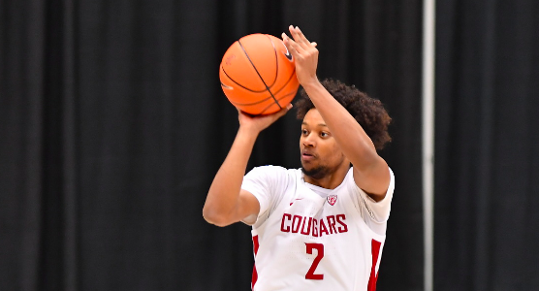

Fitzgerald-Warren is a rising senior guard who is as close to a college basketball journeyman as you can get. He started his college career at Fresno State, redshirted his sophomore year, and transferred to Collin College in Texas. At Collin College, Fitzgerald-Warren played in 21 games, averaging 11.0 points while shooting 46.2% from the floor and 41.7% from deep. While he is not a true point guard, Myles averaged an assist per game at Washington State on only 9.7 minutes per game. His 20% career assist percentage, the percentage of team field goals assisted while he was on the court, is actually higher than Bryce Barnes’s before moving to Williamsburg and slightly below Thornton Scott. Myles can bring much-needed shooting and playmaking while Tyler Rice acclimates to college ball.

With Miguel Ayesa seemingly on the outside looking in, we also are in desperate need of a three-point shooter; the Tribe were uncharacteristically terrible, 10th worst in the country, from three-point range last season. **Thomasi Gilgeous-Alexander** from the University of Evansville in the Missouri Valley Conference could be that microwave player for us. While Thomasi has not played a whole lot out there in Illinois, he is the brother of Oklahoma City Thunder breakout star Shai Gilgeous-Alexander, who is an above-average shooter. Perhaps shooting runs in his blood? With some coaching from Dane, Thomasi could bring some offensive excitement back to the squad.

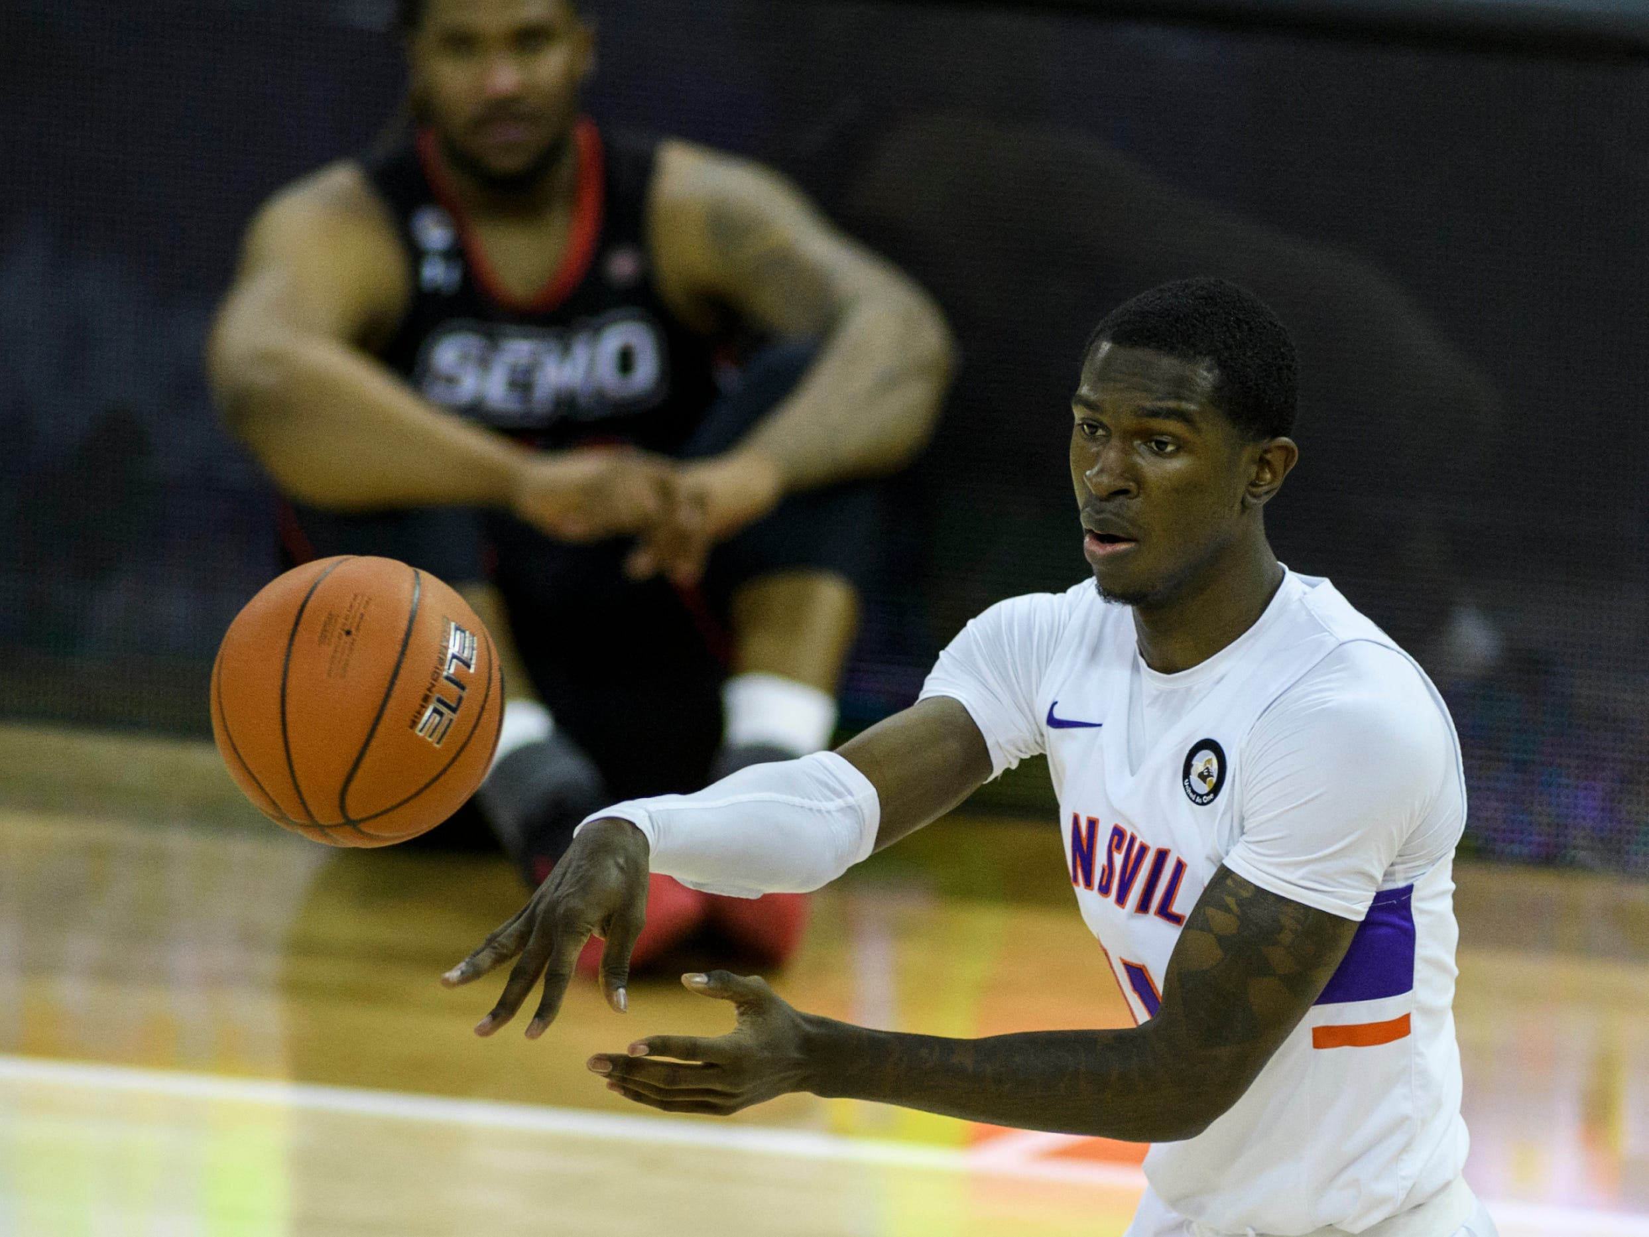

Unfortunately, there were not any transfers to replace players like Luke Loewe or upgrade at the center position in William & Mary’s price range. However, a good compromise could be to combine the best of Luke and a center. A player like Andy Van Vliet or Nathan Knight, a big guy that can shoot, could help shore up our defense and perform better in the offensive paint. **Aaryn Rai** from Dartmouth University is a 6-9’ forward with a 46% career field goal percentage, including 36% from three. Aaryn has shown substantial growth each season he has played, proving he is a substantial threat that can score, rebound, and assist.

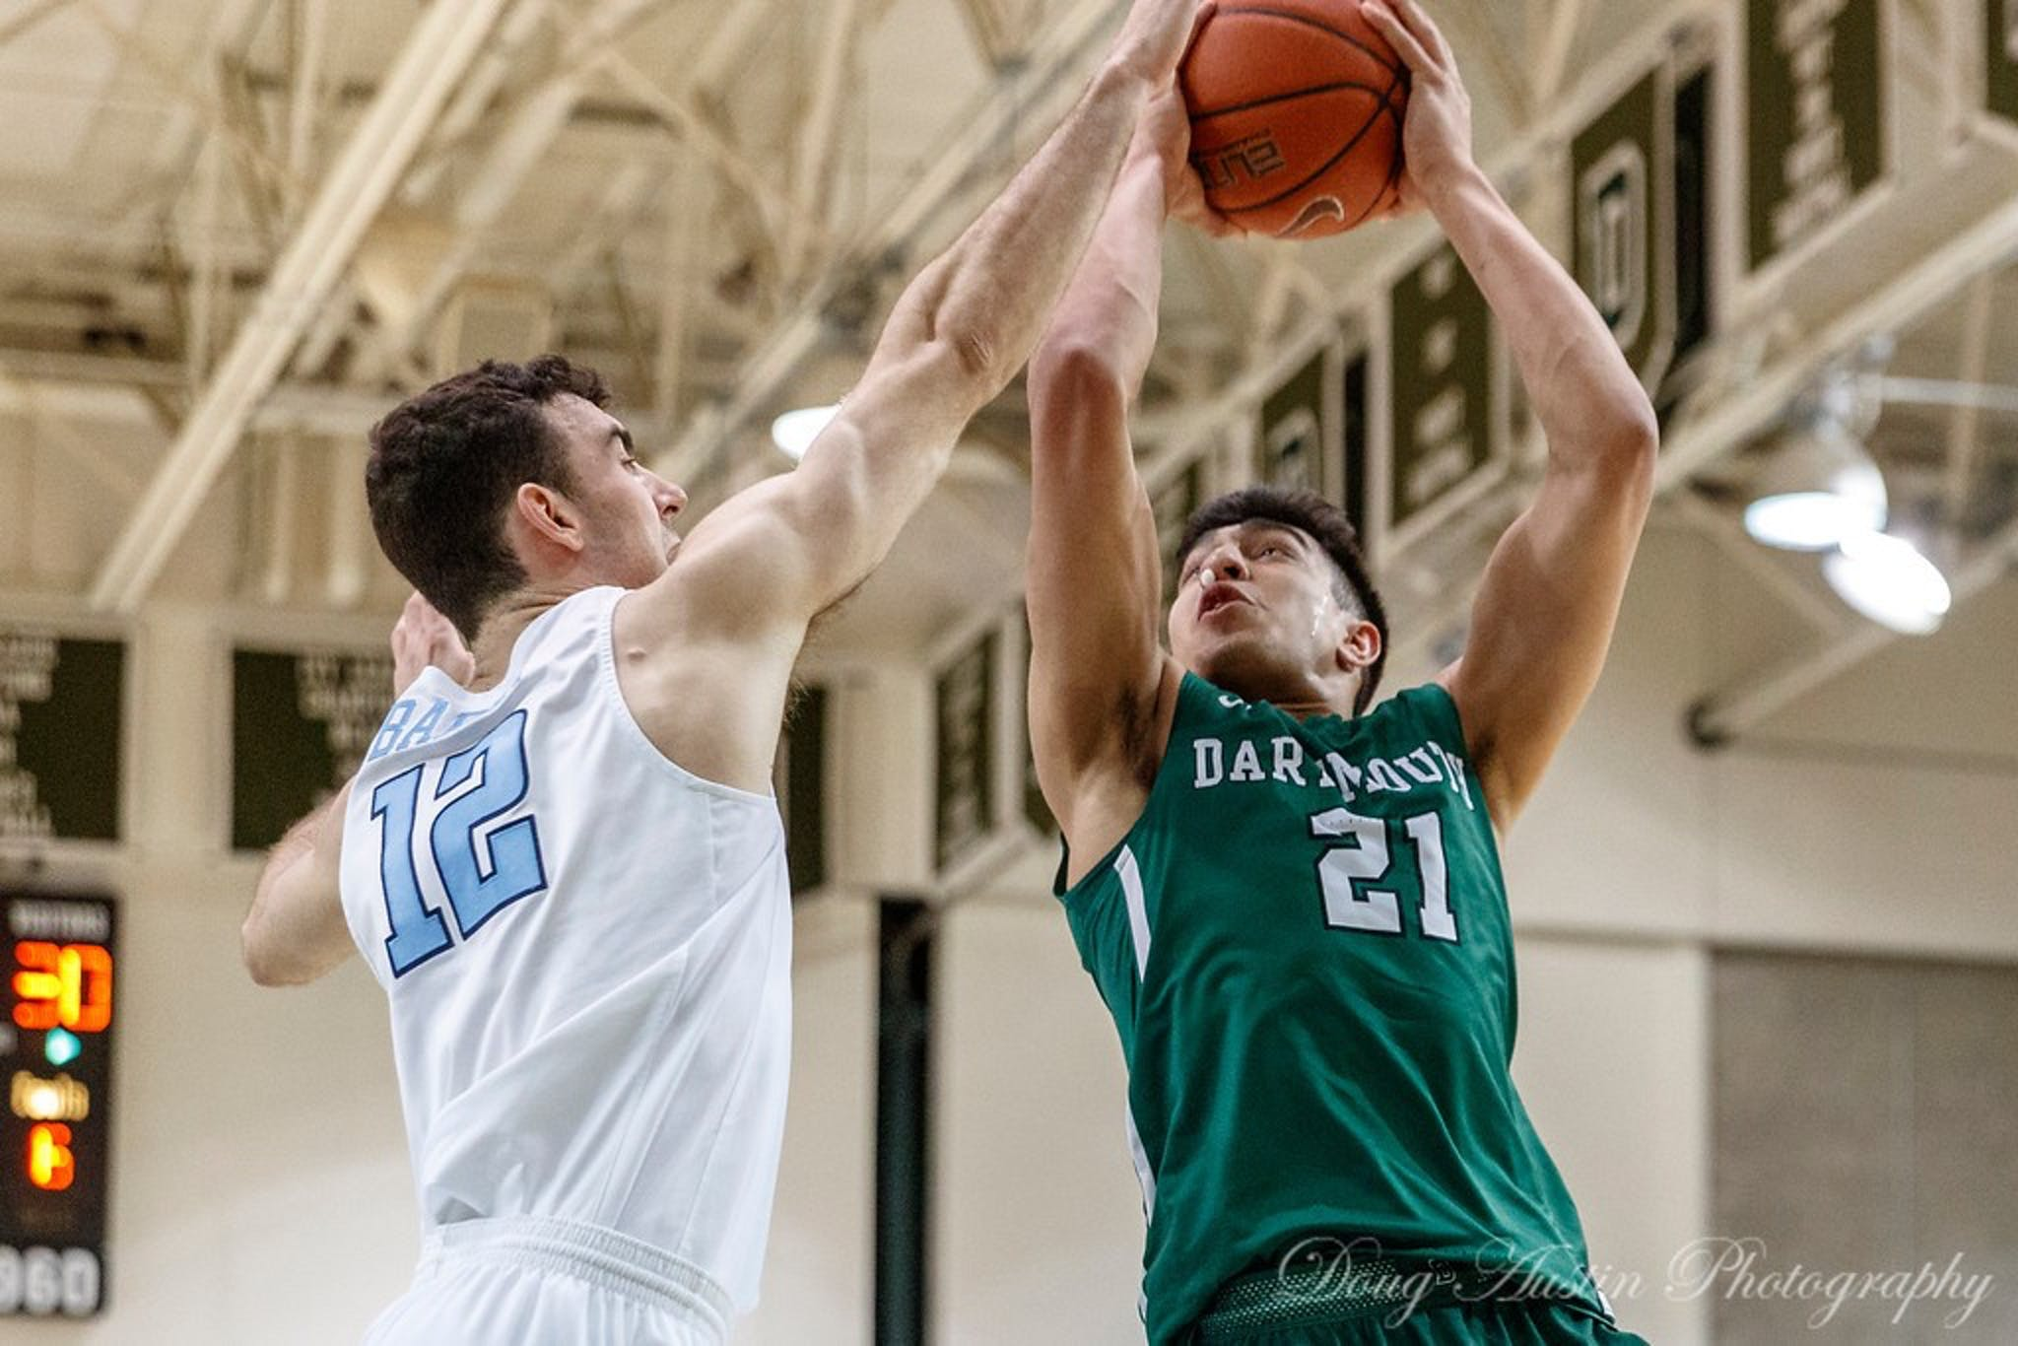

Is it likely we actually see any of these guys put on the Green and Gold this fall? Given how many times I had to rewrite this article because my option transferred, probably not. Is it more likely we nab a transfer out of the cluster 2 and 7 pile? Probably more likely. But even if we don’t net a transfer this year, which to me seems unlikely given Dane’s ability to recruit, Fischer is still a damn good coach and we have a young, promising roster. Tyler Rice, Connor Kochera, Yuri Covington and another year in the weight room for Ben Wight and Mehkel Harvey have the makings for a very solid roster. But wouldn’t it be nice if my crystal ball was correct just this one time…